**Punto 2 – Algoritmo de Dijkstra**

- Tabla inicial -> Dw > Dv + c(v, w)

|  |  |  |  |
| --- | --- | --- | --- |
| V | Dv | Pv | Conocido |
| 1 | ∞ |  | 0 |
| 2 | ∞ |  | 0 |
| 3 | 0 | - | 1 |
| 4 | ∞ |  | 0 |
| 5 | ∞ |  | 0 |
| 6 | ∞ |  | 0 |
| 7 | ∞ |  | 0 |
| 8 | ∞ |  | 0 |

**RECORDAR QUE:**

**- se selecciona el vértice NO conocido de MENOR costo -> se marca como conocido y se evalúan los adyacentes NO CONOCIDOS -> Dw > Dv + c(v, w)**

**- Dv + c(v, w) -> SUMA DEL CAMINO TOTAL HASTA ESE VÉRTICE**

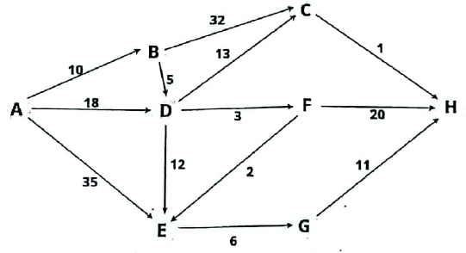

- Selecciono Vértice -> lo marco como conocido.

- actualizo costos y previos de vértices adyacentes (no conocidos):

* Dw > Dv + c(v, w) -> D(∞) > 0 + -> actualizo.

|  |  |  |  |  |
| --- | --- | --- | --- | --- |
| N° ITER | V | Dv | Pv | Conocido |
| 1° | A | 0 | - | ~~0~~/1 |
| 2° | B | ~~∞~~/10 | A | ~~0~~/1 |
| 7° | C | ~~∞~~/~~42~~/28 | ~~B~~/D | ~~0~~/1 |
| 3° | D | ~~∞~~/~~18~~/15 | ~~A~~/B | ~~0~~/1 |
| 5° | E | ~~∞~~/~~35~~/~~27~~/20 | ~~A~~/~~D~~/F | ~~0~~/1 |
| 4° | F | ~~∞~~/18 | D | ~~0~~/1 |
| 6° | G | ~~∞~~/26 | E | ~~0~~/1 |
| 8° | H | ~~∞~~/~~38~~/~~37~~/29 | ~~F~~/~~G~~/C | ~~0~~/1 |

